**ASSIGNMENT**

**Enrolling student into course**

Regular Test Case:

Project Name:

Below is the regularly used Test Case Template

Test Case ID: Test Designed By:

Test Priority : Test Designed Date:

Module Name: Test Executed By:

Test title :Student Enrollment Test Execution Date:

Description: Enrolling the students into the courses

**Pre-conditions:** The student should have valid User Id and password

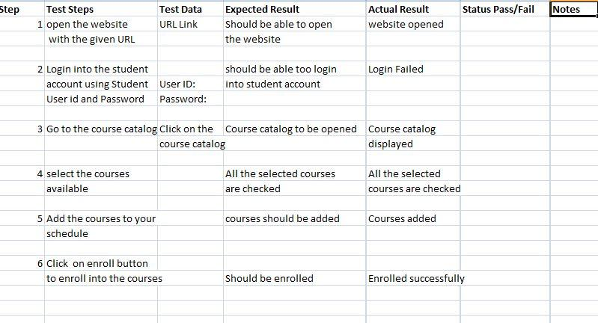

Post -Conditions:

Student has successfully enrolled into the courses and the information is saved into the database.

**Acceptance:**

**UAT**:

A process of verifying that a solution works for a user. It is a last phase of the software testing process.

During UAT, actual software users test the software to make sure it can handle real world scenarios according to specifications. It is one of the final and critical software procedures that must occur before the newly developed project is rolled out into the market.

**Goal of UAT:**

To assess if the system can support day-to-day business and the user scenarios and ensure the system is sufficient and correct for business requirements.

**Pre-requisites:**

Business requirements must be available.

Application code should be fully developed

Unit Testing, Integration Testing & System Testing should be completed.

No show stoppers, or High or Medium defects in the system integration test phase.

Only cosmetic errors are acceptable before UAT.

Regression Testing should be completed with no major defects.

All the reported defects should be fixed and tested.

Traceability matrix for all testing should be completed

UAT environment must be ready

Sign-off mail or communications from system testing team that the system is ready for UAT execution.

**Getting Started**:

Define criteria by which the software is considered to be “working”.

Create a set of UAT test cases

Run UAT tests

Record and evaluate

**Who should be involved?:**

Real end users and people using the software

Every other role and stakeholder group

Further peer group

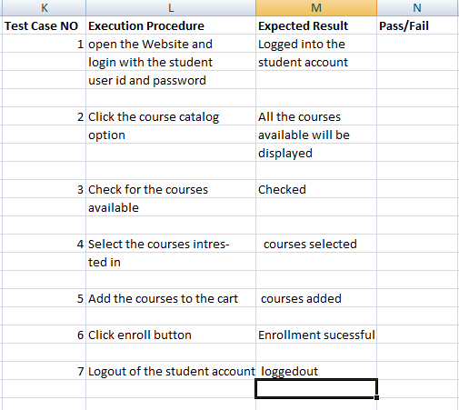

**BDD:**

Given the student is able login with User Id and Password into the website.

When the student entered wrong User Id and Password he is again in login page and tries to login

And When the student obtains the course catalog all the courses are displayed.

Then the student the selects the required courses

And Then submits them and enrollment is successful message is displayed.

**Defects:**   
  
**1)** **FaceBook and Gmail integration is not working**

Defects:

Add any gadgets by URL radio button for enable and disable is not working as expected.

The input box is unable to take the URL.

Unable to click the ADD URL button.

**2) Users not able to perform transfer money through chase.com**

Defects:

Unable to validate the account number.

Add button for adding recipient is not working

Sever problem (Unable to get the details of receiver/Unable to process the request)

Amount is not accepted

**3) Gmail registration (password is visible, Email format is not working properly)**

Username Input is not accepted

Password visibility is on

Unable to verify the User by using the Mobile number.

Unable to change the Country code for Mobile Number input.

**How to write a defect:**

Product:

Module:

Test Executed By:

|  |
| --- |
| Defect ID Def_1  Title  Summary  Description  Steps to Replicate  Severity  Priority  Status:  Produce Version/Release Version:  Attachments:  Remarks:  Reported by:  Assigned to: |

**Shopping cart functionality from amazon.com**

**Regular Test Case:**

Project Name:

Below is the regularly used Test Case Template

Test Case ID: Test Designed By:

Test Priority : Test Designed Date:

Module Name: Test Executed By:

Test title :Shopping Cart Test Execution Date:

Description: Shopping cart functionality from amazon.com

**Pre-conditions:** The User should have an Amazon account

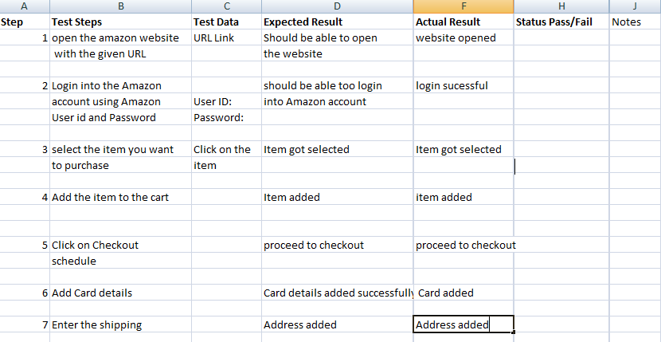

**Post- Conditions:**

User has successfully placed order with Amazon

**Acceptance:**

UAT:

A process of verifying that a solution works for a user. It is a last phase of the software testing process.

Goal of UAT:

To assess if the system can support day-to-day business and the user scenarios and ensure the system is sufficient and correct for business requirements.

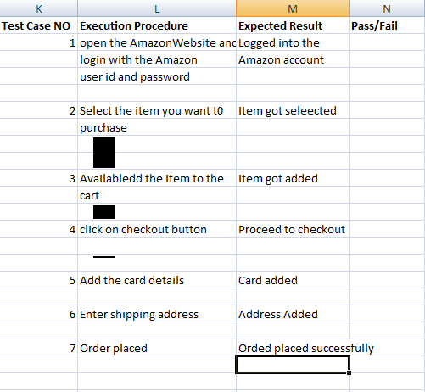

**BDD:**

Given the user is able login with User Id and Password into the website.

And When the user selected item.

Then the item got added to the cart

And Then add card details and shipping address .

Then the order is placed successfully.

**Defects:**   
  
**1)** **FaceBook and Gmail integration is not working**

Defects:

Add any gadgets by URL radio button for enable and disable is not working as expected.

The input box is unable to take the URL.

Unable to click the ADD URL button.

**2) users not able to perform transfer money through chase.com**

Defects:

Unable to validate the account number.

Add button for adding recipient is not working

Sever problem (Unable to get the details of receiver/Unable to process the request)

Amount is not accepted

**3) Gmail registration (password is visible, Email format is not working properly)**

Username Input is not accepted

Password visibility is on

Unable to verify the User by using the Mobile number.

Unable to change the Country code for Mobile Number input.

**How to write a defect:**

Product:

Module:

Test Executed By:

|  |
| --- |
| Defect ID Def_1  Title  Summary  Description  Steps to replicate  Severity  Priority  Status:  Produce Version/Release Version:  Attachments:  Remarks:  Reported by:  Assigned to: |

**Transfer amount from one account to other account:**

**Regular Test Case:**

Project Name:

Below is the regularly used Test Case Template

Test Case ID: Test Designed By:

Test Priority : Test Designed Date:

Module Name: Test Executed By:

Test title :Money transfer Test Execution Date:

Description: Transfer amount from one account to other account

**Pre-conditions:** The person should have valid user id and password

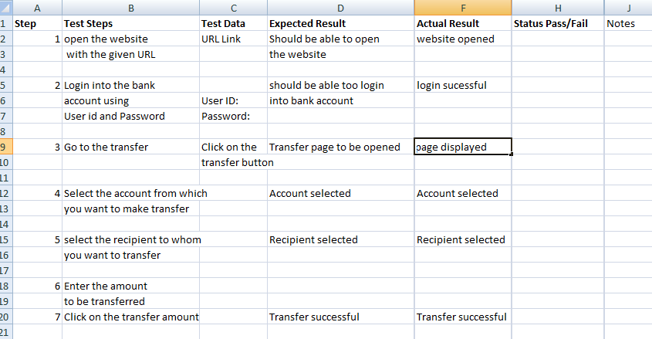

**Post- Conditions:**

Money has been transferred successfully and the activity is shown in payment history.

**Acceptance:**

UAT: (User Acceptance Testing)

A process of verifying that a solution works for a user. It is a last phase of the software testing process.

Goal of UAT:

To assess if the system can support day-to-day business and the user scenarios and ensure the system is sufficient and correct for business requirements.

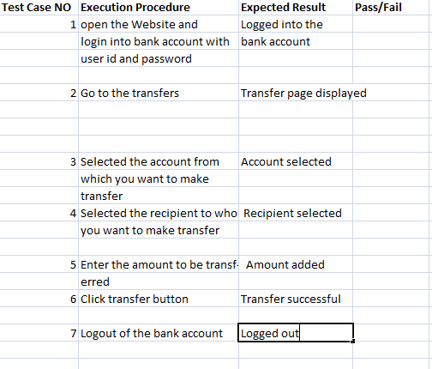

**BDD:**

Given the person is able to login with User Id and Password into the bank account.

when he will go the transfers tab and transfer page is displayed.

Then the account from which he will make transfer will be selected.

Then select the recipient to whom he has to transfer the money.

Then enter the amount to be transferred.

Then click on transfer button.

**Defects:**   
  
**1)** **FaceBook and Gmail integration is not working**

Defects:

Add any gadgets by URL radio button for enable and disable is not working as expected.

The input box is unable to take the URL.

Unable to click the ADD URL button.

**2) users not able to perform transfer money through chase.com**

Defects:

Unable to validate the account number.

Add button for adding recipient is not working

Sever problem (Unable to get the details of receiver/Unable to process the request)

Amount is not accepted

**3) Gmail registration (password is visible, Email format is not working properly)**

Username Input is not accepted

Password visibility is on

Unable to verify the User by using the Mobile number.

Unable to change the Country code for Mobile Number input.  
  
**How to write a defect:**

Product:

Module:

Test Executed By:

|  |
| --- |
| Defect ID Def_1  Title  Summary  Description  Steps to replicate  Severity  Priority  Status:  Produce Version/Release Version:  Attachments:  Remarks:  Reported by:  Assigned to: |

**1.) Gmail compose functionality:**

User must log into the website with valid id and password and should be able to Send mail with/without cc, bcc address, subject, message. Once sent, user must receive a notification saying email was sent and a popup should appear when no email id or no subject is entered.

**BDD Acceptance criteria:**

Given Gmail Login details

When Compose Gmail is selected

And user enters the cc, bcc address, subject and message

And selects an option to send

Then user’s email is successfully sent.

**2.) Transfer amount from one account to other account**

User must Login with valid user id and password and select the transfer option either from savings/checking account and selects the recipient name or email or telephone number you are sending to. Enter the amount and then select the date you wish to transfer and click transfer.

Can’t transfer negative amount or insufficient funds, from a blocked account

**BDD Acceptance criteria:**

Given User logins a Banking website

When selects transfer option from savings/checking account

And enters recipient name or email or phone number

And enters the amount along with the date

And selects transfer option

Then the user will successfully transfer the amount.

**3.) Shopping cart functionality from**[**amazon.com**](http://amazon.com/)**:**

When User logs into amazon, user should be able to select multiple items and add to cart then should be able to add discounts or coupons at the time of payment in shopping cart then the total price including shipping charges and taxes are calculated. An automatic email with an order number should be sent once the payment is made and confirmed.

The user would not be able to submit a form if all the mandatory fields are not entered.

**BDD Acceptance criteria:**

Given amazon website

When user selects multiple items

And selects add to cart

Then products are added to cart

And after adding discounts or coupons the total price is calculated along with shipping charges and taxes.

Then after payment an email with an order number is sent.

**4.) Adding dependent to existing health insurance:**

User should log into desired portal, select an option to add a dependent in the home page to the plan you choose and provide the dependent personal details and click on enroll.

**BDD Acceptance criteria:**

Given user logins a desired portal

When user selects an option to add a dependent

And provides dependent personal details

And chooses a plan

And clicks on enroll

Then the dependent is added successfully.

**5.) Remove service from mobile plan:**

When user logins a respective mobile website, from menu select a plan you are in and click on an option to remove a service. Select agree to discontinue a service.

**BDD Acceptance criteria:**

Given user logins to desired Mobile website

When chooses current plan

And selects option to remove a service from menu

And selects to deactivate the plan

And clicks on agree

Then the service is removed from a mobile plan.

**6.) Enrolling student into course:**

To enroll a student, check whether student’s GPA & Test Requirements are met and submit the Application as well as Admission documents and pay the necessary tuition fee then a student will be enrolled.

**BDD Acceptance criteria:**

Given student’s GPA and test requirements are met

When student fills all the application forms

And completes the admission documents

And pays tuition fee

Then a student will be enrolled.